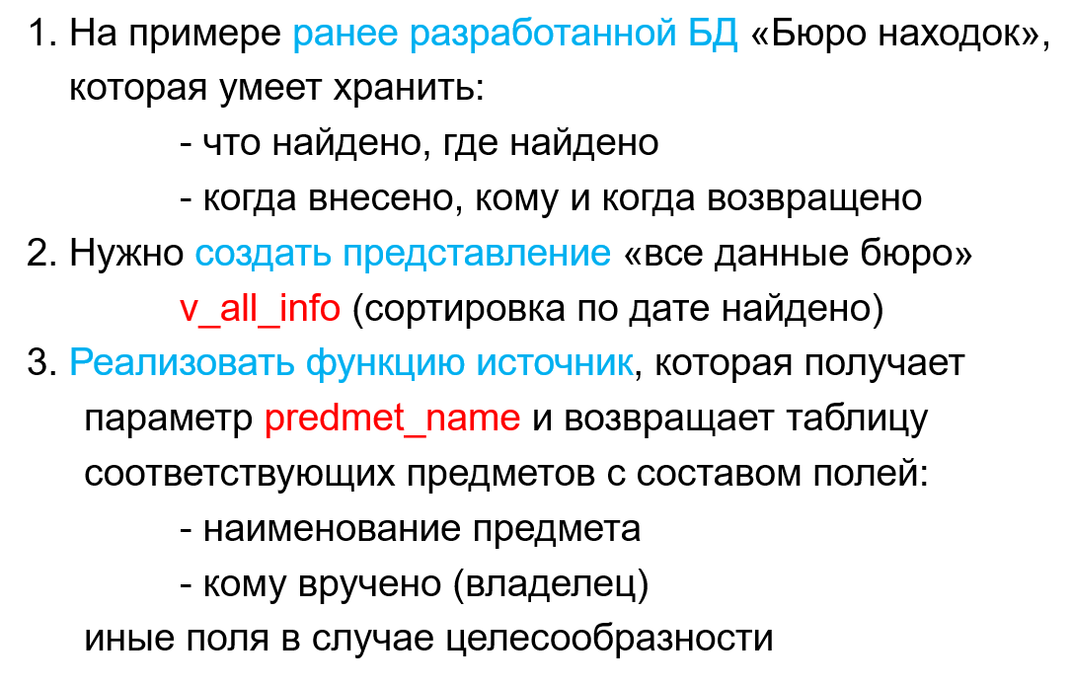
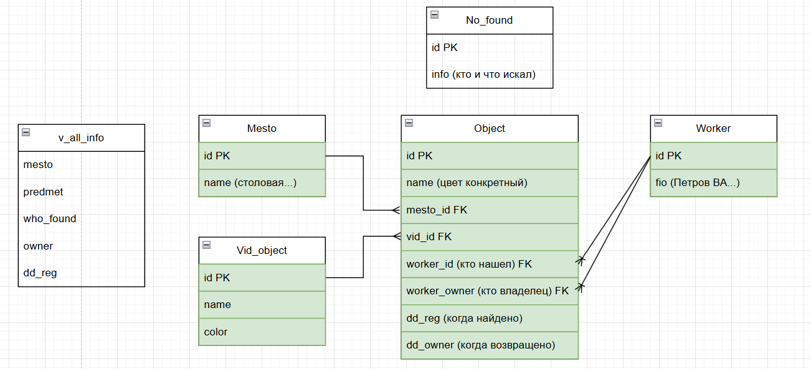
create view v_all_info as
select o.id,
m.name as mesto,
v.name as predmet,
w1.fio as who_found,
w2.fio as owner,
o.dd_reg as dd_reg
from Objects o
join Mesto m on (o.mesto_id = m.id)
join Workers w1 on (o.worker_id = w1.id)
join Workers w2 on (o.worker_owner = w2.id)
join Vid_object v on (o.vid_id =v.id )
order by o.dd_reg desc

create or replace function c1 (predmet_name text)
returns table(
object varchar(50),
own varchar(50)
) as $$
begin
return query
select
v.predmet,
v.owner
from v_all_info v
where v.predmet like '%' || predmet_name || '%';
end; $$
language 'plpgsql';

select * from c1('зонт')

select *
from v_all_info

